# On the Mark Investing Club

# Stock Presentation

# June 16, 2014

## Disclaimer

I do not know this industry or company well. All I know is what of have acquired in researching this company from their web site, annual reports, Schwab and Merrill Lynch (Bank of America).

## Selection Background

In looking for stocks to potential recommend to the club, stocks in the automotive industry are coming highly recommended. Various companies were considered such as:

* Ford (F)
* American Axle and Manufacturing Holdings (AXL)
* Magna International (MGA)

Based upon collaboration with Mark and his technical analysis model, the stock I decided to present and recommend to the club is Lear (LEA).

## Company Background

Please see the presentation to Shareholders for the most recent annual meeting. It communicated much better than I ever could about the company.

One note - They did emerge from bankruptcy in late 2009.

## Reasons for the Recommendation

#### Revenue Growth

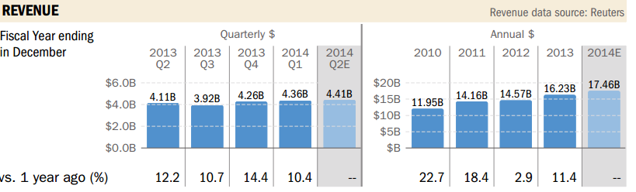

#### EPS

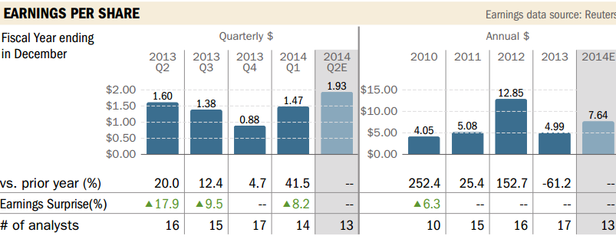

The “vs. prior year” is distorted for the following reasons:

2012 – From their 2012 Annual Report – *“$764.4 million of net tax benefits primarily related to the reversal of a valuation allowance on our deferred tax assets in the United States, as well as changes in valuation allowances in certain foreign countries, reductions in tax reserves due to audit settlements and various other items.”* This impacted the EPS by $7.70 for a net EPS of $5.15.

2009 – Emerged from bankruptcy in the last 2 months of the year. From their annual report there was – *“a gain of $1,474.8 million related to reorganization items and fresh-start accounting adjustments”* which inflates the “vs. prior year” tremendously.

#### Intrinsic Value

Courtesy of Dan Miley – *“If we assume initial earnings of $455.8M grow at a rate of 20.14%, and we discount those future earnings at a rate of 17.00%, we arrive at a net present value for the company's next 10 years of earnings of $5.29 billion. To account for potential earnings beyond the 10th year, we estimate a growth rate of 6.00%, a discount rate of 12.00%, and we arrive at a continuing value of $10.49 billion. To complete the calculation we add these two figures together, subtract the long-term debt for LEA ($1.07 billion), and divide by the outstanding shares (81.3 million) to get a per share intrinsic value of* ***$180.99****.*”

#### Analyst Recommendations and 12 month projections

|  |  |  |  |  |  |  |  |  |
| --- | --- | --- | --- | --- | --- | --- | --- | --- |
| **Symbol** | **Name** | **Last Price** | **12 Month Objective (BofA)** | **Potential** | **BofA Rating** | **Morningstar** | **S&P Capital** | **Schwab** |
| LEA | Lear Corporation | $ 89.04 | $ 110.00 | 24% | Buy | -- | Buy | A |

#### Technical Analysis

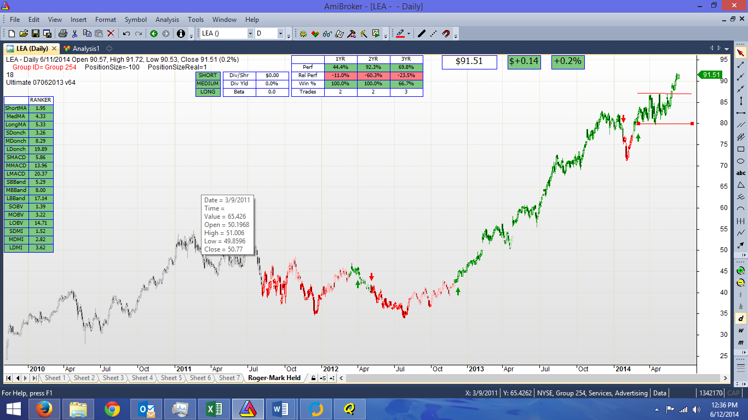

## Backup Documentation

Annual Shareholders Presentation

Schwab Equity Report

S&P Capital IQ Report